AIDRES
“Advancing industrial decarbonization by assessing the future use of renewable energies in industrial processes”

Methodology used to map the industrial plants in the EU
(D3.2)
-
Supporting document to the industrial plants database

Prepared for the European Commission, DG ENER,
under service contract N° ENER/2020/OP/0011/C2/SER/2019-569/SI2.840687

EUROPEAN COMMISSION
Directorate-General for Energy
Directorate B — Just transition, consumers, energy efficiency & innovation
Unit B.5 — Innovation, research, digitalisation, competitiveness
Contact: Eric Lecomte
E-mail: eric.lecomte@ec.europa.eu
European Commission
B-1049 Brussels

Authors :

Wim Clymans ; Flemish Institute for Technological Research (VITO), wim.clymans@vito.be
Karolien Vermeiren ; Flemish Institute for Technological Research (VITO)
Leen Van Esch ; Flemish Institute for Technological Research (VITO)
Lorenz Hambsch ; Flemish Institute for Technological Research (VITO)

Contributors :

Frank Meinke-Hubeny ; Energyville | Flemish Institute for Technological Research (VITO)
Joris Valee ; Energyville | Vlaamse Flemish Institute for Technological Research (VITO)
Juan Correa Laguna ; Energyville | Flemish Institute for Technological Research (VITO)
Luc Girardin ; École Polytechnique Fédérale de Lausanne (EPFL)
Francisco Mendez Alva ; Ghent University (UGent)

In collaboration with Energyville/VITO, Catholic University Leuven, Ghent University, IPESE EPFL, Vrije Universiteit Brussel and DECHEMA

AIDRES
“Advancing industrial decarbonization by assessing the future use of renewable energies in industrial processes”

Methodology used to map the industrial plants in the EU
-
Supporting document to the industrial plants database

Manuscript completed in June 2023
First edition: July 2023

LEGAL NOTICE
This document has been prepared for the European Commission however it reflects the views only of the authors, and the European Commission is not liable for any consequence stemming from the reuse of this publication. More information on the European Union is available on the Internet (http://www.europa.eu).
PDF | ISBN [number] | ISSN [number] | doi:[number] | [Catalogue number]

Luxembourg: Publications Office of the European Union, 2023

© European Union, 2023
The reuse policy of European Commission documents is implemented by the Commission Decision 2011/833/EU of 12 December 2011 on the reuse of Commission documents (OJ L 330, 14.12.2011, p. 39). Except otherwise noted, the reuse of this document is authorised under a Creative Commons Attribution 4.0 International (CC-BY 4.0) licence (https://creativecommons.org/licenses/by/4.0/). This means that reuse is allowed provided appropriate credit is given and any changes are indicated.
For any use or reproduction of elements that are not owned by the European Union, permission may need to be sought directly from the respective rightholders.

Table of Contents

1. Brief summary: AIDRES project 6
2. Mapping industrial sites per sector (Figure 1) 8
3. Inventory of industrial parameters per sector and production route (current technology options) 11
3.1. General Approach (Figure 3) 11
3.2. Sector specific overviews 16
3.2.1. Public database approach 16
3.2.2. Emission factor approach 21
3.2.3. Pareto approach 30

- Brief summary: AIDRES project
In recent years many studies have been published aiming to gain a better understanding of potential pathways towards carbon neutrality of various end-use sectors in general and Energy Intensive Industries in particular. But previous studies have to a large extent focused on carbon-neutrality pathways for individual sectors in isolation, based on generic processes assumptions. At the same time the successful transformation of Energy Intensive Industries will play a pivotal role if the EU Green Deal and Fit for 55 (FF55) strategies will prove successful, from an environmental and economic point of view.

The AIDRES project (Advancing industrial decarbonization by assessing the future use of renewable energies in industrial processes), builds a spatially explicit database covering future demands for renewable energy carriers (electricity, gases, liquid fuels and heat) representing future pathways for 6 energy intensive energy industrial sectors (steel, chemical, cement, glass, fertilisers and refineries) in the European Union. More specifically the AIDRES project aims to:
- Identify the magnitude of renewable energy demand for potential technological innovation paths of energy intensive industries towards carbon neutrality and more circularity, at medium (2030) and long term (2050).
- Compare effectiveness, efficiency and investment needs of technological innovation path options.
- Identify potential symbiosis with other sectors.
- Determine where resulting renewable energy demands will be located within the EU.

Work Package 1 - Systematic and comparative analyses technological innovation paths in energy intensive industrial sectors, and potential symbiosis between industries and other sectors
This WP is designed to develop models for present and future technologies applicable for the selected energy intensive industries steel, chemical, cement, glass, fertilisers and refineries within the European context. The methodology leverages on the existing (EPOS Project) blueprint models for industries and construct high-level models of energy-intensive processes in the identified sectors. As a subsequent step, possibilities of industrial symbiosis between sectors and in geographical regions identified in WP2 will be evaluated. This approach will generate solutions (technological pathways) for transitioning sectors to more sustainable future operation and be documented for the years 2030 and 2050.

Work Package 2 - Mapping EU-industries renewable energy demand focuses on analysing and determining where the future demand for the associated energy inputs is located within the EU. Hence, a mapping of all relevant industrial plants for the considered sectors is carried out and forms the base of this study. Next, supporting industrial parameters will be derived at the level of industrial plants which allow WP1 to calculate energy and feedstock inputs and to identify symbiosis opportunities. The outcome is a geographical database at the level of plant location and aggregated at NUTS3 granularity; it combines information on the type of installations, industrial parameters and current and future energy and material demands, production rates and GHG emissions for the defined model solutions within WP1.

The document describes the methodology used to model and characterize the industrial products in the EU (as part of WP1). Results can be consulted through the Energy and Industry Geography lab on the EU Science Hub, following this link:
https://data.jrc.ec.europa.eu/dataset/14914982-70a9-4d1d-a2fc-cdee4a1d833d

Work Package 3 - System Prefeasibility Analysis Adequacy and barrier screening concentrates on the analysis and determination of key system adequacy indicators for the future European power grid. This is achieved by integrating the AIDRES-generated electricity demand figures with existing scenarios on system development, specifically the EU Reference Scenario 2020 and the Ten-Year Network Development Plan (TYNDP) developed by ENTSO-E and ENTSOG. The projected power system, resulting from this integration, is analysed to gain insights into the expected regional self-sufficiency and the principal power system flows and barriers. This work package also offers guidance for further system assessments, thereby facilitating a comprehensive understanding of the potential challenges and opportunities in the transition towards a carbon-neutral power system in Europe.

“The information and views set out in this report are those of the author(s) and do not necessarily reflect the official opinion of the Commission. The Commission does not guarantee the accuracy of the data included in this study. Neither the Commission nor any person acting on the Commission’s behalf may be held responsible for the use which may be made of the information contained therein.”

- Mapping industrial sites per sector (Figure 1)
- The EUTL database 2020 provided by DG CLIMA contains all energy intensive production installations (>20MW) and forms the basis for the AIDRES project
- Production installations are classified into industrial sectors using the EUTL activity codes (see Annex 1 with the classification)
- Selection of relevant production installations (total number - 1758):
  - Sector: Chemical, Fertiliser, Refinery, Cement, Glass and Steel
  - Actively reporting on ETS in 2019
- Connection with external databases for classification and verification purposes only:
  - NACE-codes: Statistical Classification of Economic Activities in the European Community, Rev. 2 (2008)
  - E-PRTR production installations
  - Hotmaps study result
- Geographical analysis:
  - Mapping production installations via Google API
    - verification for accuracy with E-PRTR, hotmaps coordinates and visual evaluation, and where needed manually corrected (131 out of 1758)
  - Coupling with NUTS3 region based on geographical location
  - Aggregating installations at the production site level (total number - 1534): using a unique EUTL combination of
    - Sector classification
    - Account holder name
    - Postal code
A production site is the geographical unit that combines production installations from one sector and specific company in space. For example, a chemical production site (BASF Ludwigshafen) can group more than 40 production installations from the chemical sector at one location.

RESULT: AIDRES geographical database with all EUTL production installations and derived production sites (see Figure 2) in the EU27 classified by chemical, fertiliser, refinery, cement, glass and steel sector.

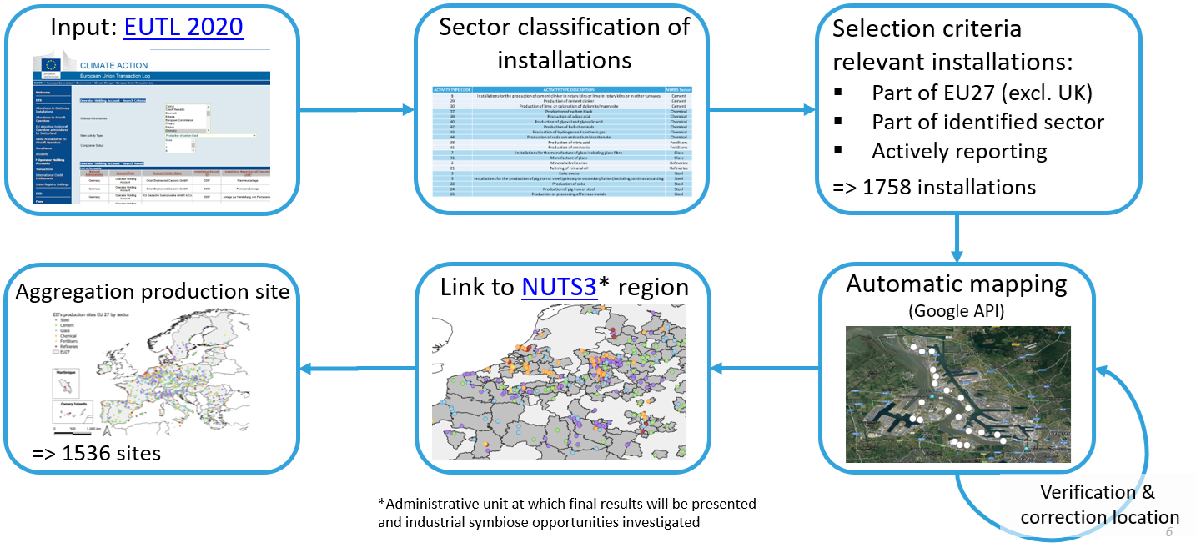
Figure 1 Schematic overview of the approach of task 1 in WP2: Map industrial sites in the EU27

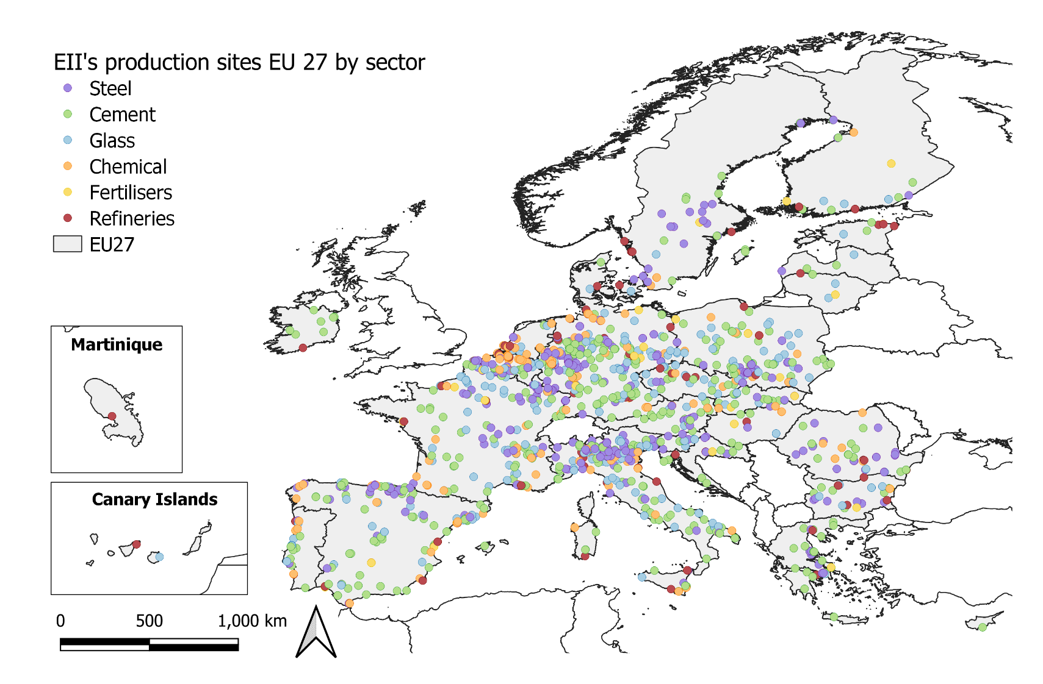
Figure 2 EUTL production sites in the EU27 classified by chemical, fertiliser, refinery, cement, glass and steel sector (AIDRES project, 2020).
- Inventory of industrial parameters per sector and production route (current technology options)
  - General Approach (Figure 3)
In order to model the future energy and material requirements for a production site with the proposed blue print methodology (EPOS project) - we require information per production site on:
- Current technology options being the production route(s) at the site.
- Industrial parameters like production capacity (kt yr⁻¹) and/or rate (kt yr⁻¹) per production route.
The focus is on using openly available databases (e.g. EUROFER, CONCAWE, Fuels Europe) and input provided directly by the sector associations of the individual sectors. Sector associations were contacted to provide relevant input to support this subtask (e.g. CEMBUREAU, CEFIC, Fertilizer Europe):
- Verification (and/or completion) of plant locations
- Insight regarding site classification
- Relevant production routes (for each location)
- Review of our simplified production route model (e.g. container glass)
- Production capacities and/or rate per production site
Depending on the availability of open-data sources, the complexity of the production routes present within a sector and how to achieve minimal representativeness of a sector in terms of verified emissions (>80%), we decided to use a sector specific approach to map relevant production routes and production capacities/rates per production site. Generally, three different approaches were taken:
- Public database: Used production capacity (open data) provided by sector federations to link with production sites, and where possible a default or country-specific utilization factor was applied to estimate production rates = > Steel and Refinery sectors
- If a public database with production data was not available – two alternative approaches were applied:
- Pareto approach: Desktop inventory of reported production capacity data (i.e. annual reports, factbooks, site fact sheets, scientific publications, newspaper articles, permit reports and national databases) for the largest production sites which are cumulative responsible for 80% of the verified emissions (2019). A default production capacity is attributed to the production sites responsible for the remaining 20% of verified emissions = > Chemical and fertiliser sectors
- Emission factor: If >50% of the sites are responsible for 80% of the verified emissions a complete desktop study is not feasible. Instead reported ETS emissions are converted to production rates using production route specific emissions factor (t CO2/t product). Emissions factors are derived from recent sector and EC reports. To validate the approach, we verified derived production rates with reported production capacities at the level of a site for a representative subset, country and sector (i.e. annual reports, factbooks, site fact sheets, scientific publications, newspaper articles, permit reports and national databases) = > Cement and glass sectors
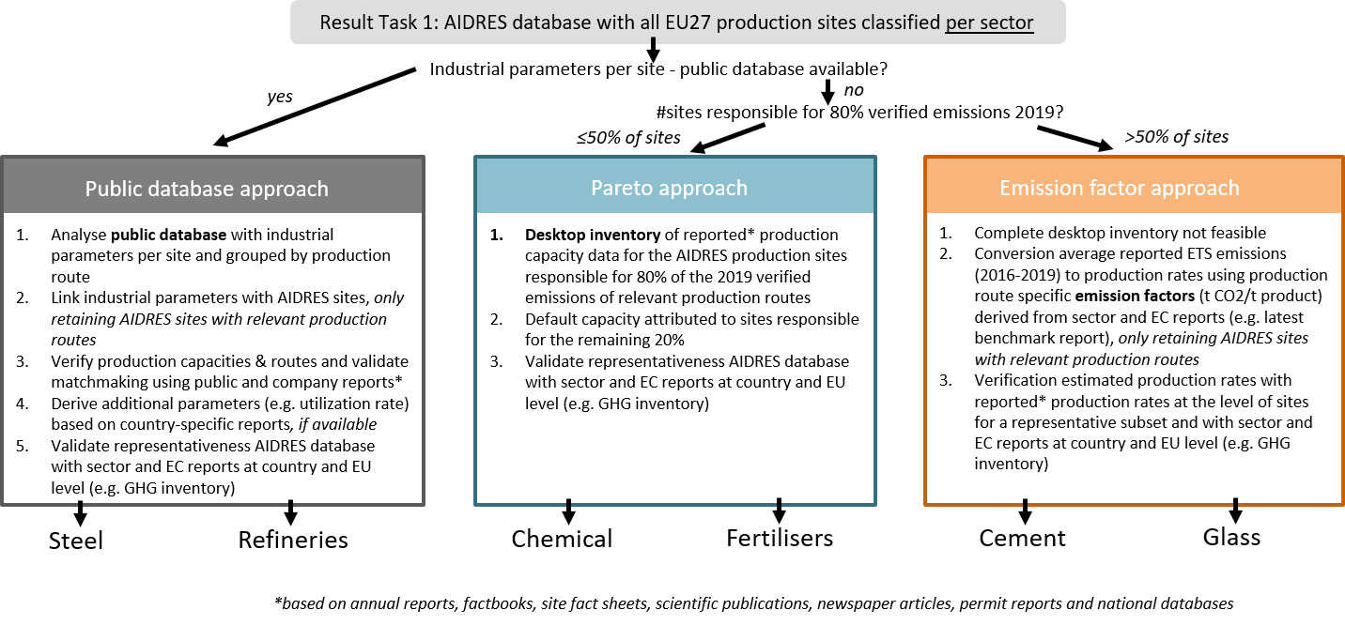
Figure 3 Schematic overview of the approach of task 2 in WP2: INVENTORY OF INDUSTRIAL PARAMETERS PER SECTOR AND PRODUCTION ROUTE for CURRENT TECHNOLOGY OPTIONS

Table 1 Per AIDRES sector an overview of the number of sites per production routes and industrial parameters (Production Capacity, Production Rate and Utilization rate) and it’s representativeness for the 2019 verified emissions in the EUTL db.
Sector | Production route | #Sites | Industrial parameters |  |  | %Verified emissions 2019 | Remark
 |  |  | Prod Cap | Prod Rate | Util
 |  |  | -------10⁶ ton yr⁻¹------- |  | [-]
Public database
Steel
 | Production | 148 | 195 | 160 | 0.82 | 90%
 | Primary | 26 | 110.6 | 92.8 | 0.84
 | Secondary | 122 | 85 | 65.7 | 0.77
 | Processing | 238 |  |  |  | 10% | Not included in WP1
Refinery
 | Active | 89 | 608 |  |  | 93%
 | Not active | 19 |  |  |  | 7% | Not included in WP1
Emission factor based
Cement
 | Cement | 207 |  | 173 |  | 80% | EF of 0.634 tCO₂/t cement, estimate for all sites available
 | Lime | 223 |  |  |  | 20% | Not included in WP1
Glass
 | Container | 186 |  | 10 |  | 61% | EF of 0.393 tCO₂/t glass, and corrected for an avg cullet ratio of 54%
 | Flat | 42 |  | 32 |  | 32% | EF of 0.509 tCO₂/t glass
 | Fibre Glass | 32 |  | 2.1 |  | 6% | EF of 0.414 tCO₂/t glass
Pareto approach
Fertiliser |  |  |  |  |  | ±100%
 | Ammonia | 25 | 14.7
 | Nitric acid | 26 | 11.8
 | Derivates | 29 | 34.1 |  |  |  | Includes urea, ammonium nitrate etc
 | Combined | 3 | 2.8 |  |  |  | Reported production data was not split by product type (ammonia, nitric acid, derivates)
Chemical |  |  |  |  |  | ±95%
 | Cracker | 130 | 44.0 |  |  |  | Combining results captured in desktop research (see table Table 18), data integrated refinery sites and a default PC for the remaining sites
 | Organic synthesis | 157 | 26.0 |  |  |  | Combining results captured in desktop research (see table Table 18) and a default PC for the remaining sites
 | Polymers | 155 | 31.5 |  |  |  | Combining results captured in desktop research (see table Table 18) and a default PC for the remaining sites
 | Carbon black | 6 |  |  |  |  | Not included in WP1
 | Soda | 12 | 4.2 |  |  |  | Not included in WP1
 | Industrial and synthetic gas | 22 |  |  |  |  | Not included in WP1

  - Sector specific overviews
    - Public database approach
Steel sector
- Identified production routes (current technology options)
Steel is produced all over the EU, primarily using the Blast Furnace - Basic Oxygen Furnace (BF-BOF) 'primary' steelmaking route and via the 'secondary' Electric Arc Furnace (EAF) route. The steel processing industry is well represented in Europe and complementary to the steel production industry. EUROFER reports a total of 500 steel production and processing sites across 23 EU member states of which many are EUTL registered (2020 EUROFER; accessed: 1/04/2021).

Table 2 Number of steel production sites (202) per production route as derived from the EUTL database
Production route | Description | Sites
Primary production | Blast Furnace – Basic Oxygen Furnace (BF-BOF) | 26
Secondary production | Electric Arc Furnace (EAF) - conventional | 122
Processing | Hot/cold rolling, cutting, etc. | 235

The AIDRES project focuses on primary and secondary steel production sites only. Steel processing plants are not included in the inventory of industrial parameters and modelling exercise. Crude steel production sites consume most of the materials and energy to drive their processes while at processing sites, the consumption of energy sources is limited. The 148 production sites represent approx. 90% of the emission allocations in 2019 in the steel production industry while the processing industry is responsible for the remaining 10%.

- Industrial parameters
The EUROFER database⁷ which includes production capacity (kt yr⁻¹) per production site in Europe, and which is classified by technology option, forms the basis of the industrial parameter collection for the steel sector. EUROFER production capacities per site are linked to the AIDRES sites using corresponding geographical information. Public reports, company (e.g. Arcelor Mittal) and sector-specific websites (e.g. https://globalenergymonitor.org/) were queried to confirm production capacities and used to validate the matchmaking.

Subsequently, the world steel association reports on annual crude steel production rates per country. Average country-specific utilisation rates are derived by comparing reported production capacity (EUROFER) and crude steel production rates (World Steel Association) per country. This country-specific utilization rate is applied to calculate production rates at site level.

Table 3 Relevant industrial parameters and data-sources for the steel sector.
Production route | Sources | Description
Production capacity (kt yr⁻¹) | EUROFER | Map of EU steel production sites classified by production route.
Production rate (kt yr⁻¹) | World Steel Association | Derived from country specific utilization rates (see below).
Utilization rate (-) | World Steel Association | World Steel Association reports on crude steel production per country. Average country-specific utilisation rates are derived, and applied to calculate production rates at the site level.

- Overview production rates per site and per route
According to the AIDRES database, the sector currently produces about 160 million ton steel annually in the EU27, and this with an installed capacity of about 195 million ton. About 58% is produced following the primary production route while 42% follows the secondary EAF production route. EUROFER reports on average about 160 million tons for the EU27 in the 2015-2019 period (excl. UK) which is in line with our estimates.
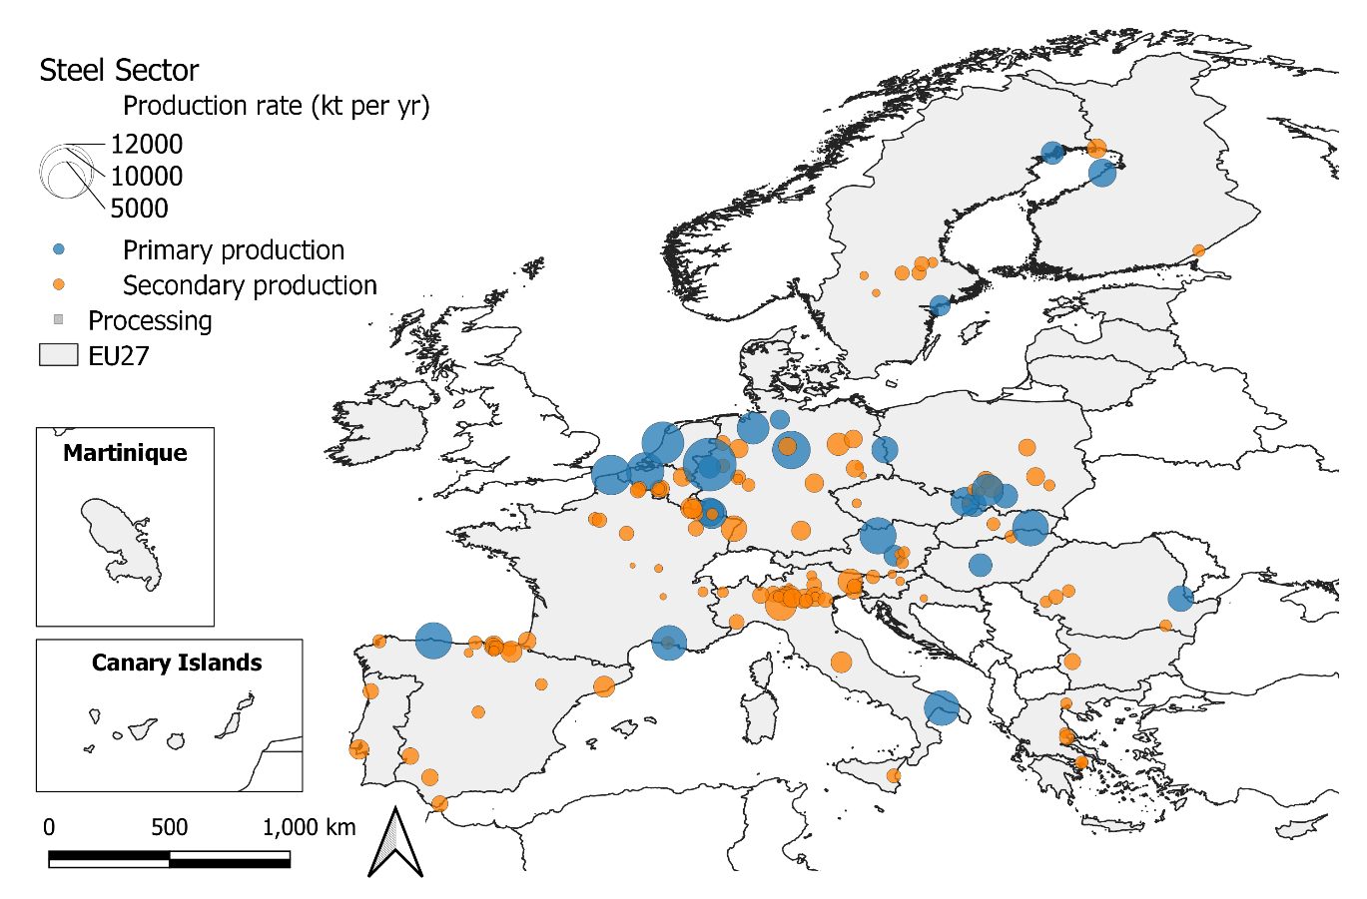
Figure 4 Production rate (kt yr⁻¹) for steel production sites in the EU27.

The AIDRES project inventorised steel production rates (kt yr⁻¹) per ETS site using publicly available data (see above). A comparison with country specific production rates as reported in the annual EU greenhouse gas inventory 1990-2019 and inventory report 2021 (EU NIR) shows that country specific steel production rates as reported by national authorities corresponds well with production rates included in the AIDRES database.

Table 4 Country specific comparison of steel production rates as included in the AIDRES database and reported in the annual EU greenhouse gas (GHG) inventory report (2021).
Country | Production rate (kt yr⁻¹)  AIDRES (2020) | GHG inventory (2018) | Ratio (AIDRES/CRF)
Austria | 6885 | 6176 | 1.1
Belgium | 7990 | 7925 | 1.0
Bulgaria | 666 | 684 | 1.0
Czech Republic | 4939 | 5034 | 1.0
Germany | 42536 | 42435 | 1.0
Spain | 14321 | 14794 | 1.0
Finland | 3950 | 4074 | 1.0
France | 15388 | 15449 | 1.0
Greece | 1467 | 1467 | 1.0
Croatia | 89 | 136 | 0.7
Hungary | 1979 | 1989 | 1.0
Italy | 23999 | 24503 | 1.0
Lithuania | 2327 | 2228 | 1.0
Netherlands | 6813 | 7027 | 1.0
Poland | 9817 | IE | -
Portugal | 1700 | 2254 | 0.8
Romania | 3550 | 3701 | 1.0
Sweden | 4653 | 1839 | 2.5
Slovenia | 654 | 667 | 1.0
Slovakia | 5130 | 4642 | 1.1
EU27 | 158,853 | 147,023 | Avg. 0.98
*Abbreviations: IE (Included Elsewhere)

Refinery sector
- Identified production routes (current technology options)
The focus lays on mainstream and specialized refineries for crude oil and biomass as feedstock. Shale-based production routes are not included in the inventory of industrial parameters and modelling exercise. The AIDRES database includes 108 production sites of which 89 are currently active (2021). These are responsible for 93% of the verified emissions (2019) within the EUTL database.

Table 5 Number of refinery production sites (2020) per production route as derived from the EUTL database.
Production route | Number
Crude oil refinery | 89
Not active/refinery | 19

- Industrial parameters:
The Concawe database reports the production capacity (Mt yr⁻¹) evolution of the refining industry for each year from 2009 to 2020, and for each production site. Concawe production capacities were linked to AIDRES sites using corresponding geographical information. Public reports, company and sector-specific websites (e.g. Petrochemicals Europe; Fuels Europe; S&P Globals) were queried to confirm production capacities, validate the matchmaking and identify if the refinery is still active (82 out of 108) and if it uses crude oil or biomass as a feedstock.

The Petrochemicals Europe Database reports which sites are integrated refinery and cracker sites. Ideally, the chemical sector (see section 1.2.6) already includes an overview of all ETS registered cracker sites in the EU27. However, a location-based comparison between the EUTL database and petrochemicals Europe database showed that several integrated sites were merely reported as refineries and no cracker installations were identified in the EUTL database. For these sites a correction was made to include the missing crackers in the chemical sector (see section 1.2.6 Chemical sector).

Table 6 Relevant industrial parameters and data-sources for the refinery sector.
Data | Source | Description
Production capacity (kt yr⁻¹) | Concawe | Concawe developed a comprehensive map showing the location of the mainstream and specialised refineries processing crude oil in Europe.

- Overview production capacity per site and per route
According to the AIDRES database, the refinery sector has a refining capacity in 2020 of 608 million ton crude oil annually in the EU27. Fuels Europe reports a primary refining capacity of 662 million tons in 2020 (incl. EU27+UK+Norway+Switzerland) which is in line with our estimates.
The modelling effort focuses on the production of light liquid fuels (LHV) at a ratio of 600t per 1kt of crude oil. Other products are not considered in the model. The light liquid fuels refining capacity in EU27 equals 388 million ton.
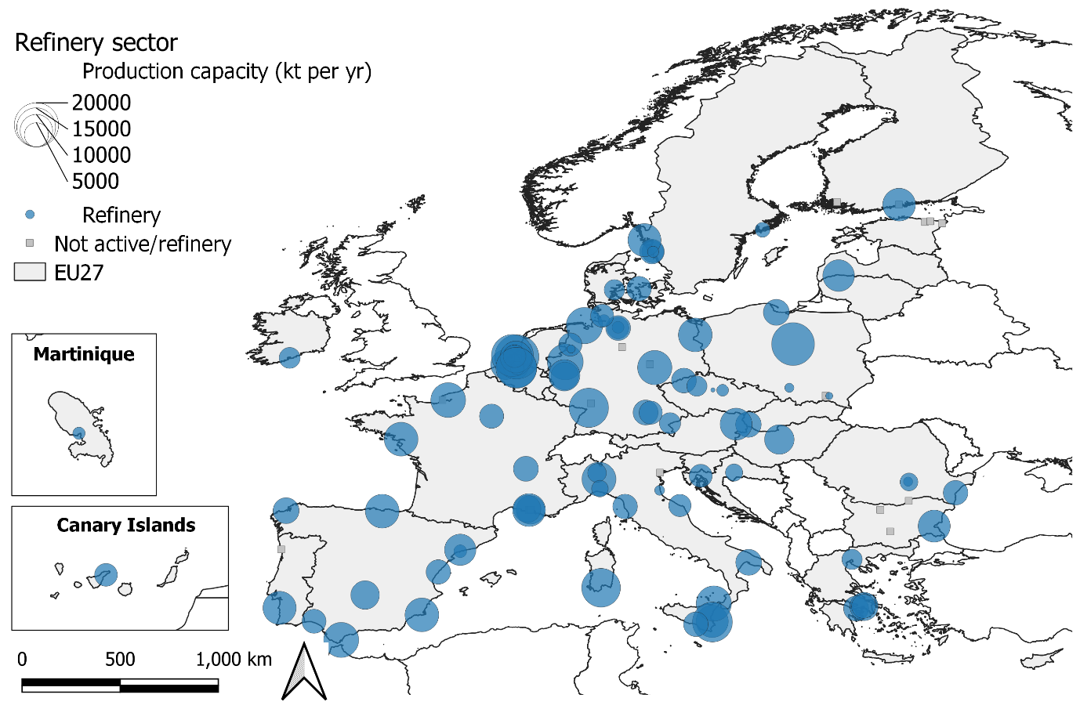
Figure 5 Production rate (kt yr⁻¹) for refinery production sites in the EU27.

    - Emission factor approach
Cement sector
- Identified production routes (current technology options)
We focus on the cement production process within the AIDRES project. Lime is an input material for e.g.: steel production, construction materials, plastics, and is not considered as an integral part of the cement sector. The classification of sites into a production route is based on ETS activity codes and where needed validated and reclassified based on the Nace activity code (see section 1.1). The AIDRES database includes 430 cement and lime production sites of which 207 are cement production sites. Those 207 are responsible for 77% of the verified emissions (2019) within the EUTL database.

Table 7 Number of cement and lime production sites (2020) per production route as derived from the EUTL database
Production route | Number
Cement | 207
Lime | 223

- Industrial parameters
There is no public database available with cement production capacity and rates at the level of production sites within the EU27. For cement production more than 50% of the sites (140 out of 207) are responsible for 80% of the verified emissions (Pareto-approach) and therefore a complete desktop study to collect industrial parameters per site is not feasible. Instead emissions factors are derived from recent sector and EC reports (Table 8) and combined with average verified emissions for the period 2016-2019 as reported in the EUTL database to estimate clinker production rates (kt yr⁻¹) per site.

Table 8 Average emission factor EU27 for the cement sector
Average emission factor EU
Cement EF¹ |  | 0.634 | tCO₂/t Cement
Clinker Cement Ratio² |  | 0.730 | tclinker/tcement
Clinker EF |  | 0.868 | tCO₂/t clinker
Production of cement by type
 |  | EF³ | Share⁴
grey clinker |  | 0.812 | 81%
white clinker |  | 1.114 | 19%
AVG Clinker EF |  | 0.868

¹Derived from average clinker EF using the clinker cement ratio - https://climate.ec.europa.eu/system/files/2016⁻¹1/bm_study-cement_en.pdf
²CEMBUREAU – low carbon economy - https://lowcarboneconomy.cembureau.eu/5-parallel-routes/resource-efficiency/clinker-substitution
³International Energy Agency – Low carbon transition in the cement industry reports clinker EF - https://iea.blob.core.windows.net/assets/cbaa3da1-fd61-4c2a-8719-31538f59b54f/TechnologyRoadmapLowCarbonTransitionintheCementIndustry.pdf
⁴Share clinker type based on production data in GNR project (2018) - https://gccassociation.org/gnr/

For a random sample of cement production sites, production capacities are derived from literature and online reports and compared with estimated production capacities using the emission factor methodology. Applying an average European utilization conversion factor of 0.8 results in a good approximation of reported capacities (Figure 6).

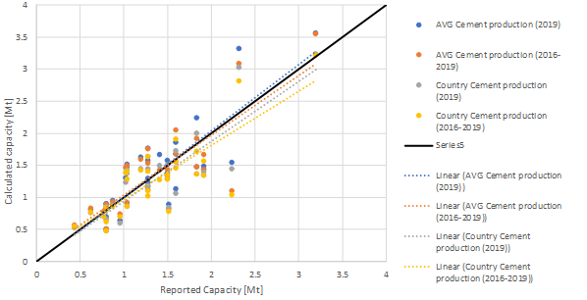
Figure 6 Validation of emission factor based estimates of production rates using different methodologies with reported production rates/capacities at the level of cement production sites.

- Overview production capacity per site and per route
According to the AIDRES database, the cement sector has a production rate of 173 million ton annually in the EU27. CEMBUREAU (Table 9) report a production of 181 million tons in 2018 (excl. UK) which is in line (+7%) with our EU27 estimate.

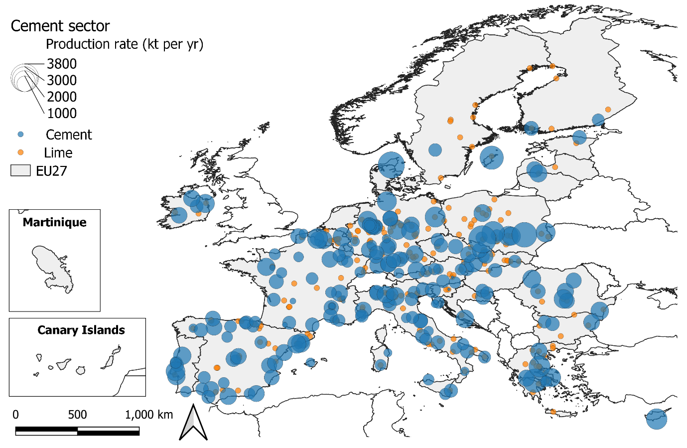
Figure 7 Production rate (kt yr⁻¹) for cement production sites in the EU27.

A comparison with country specific cement production rates as reported in the Annual EU greenhouse gas inventory 1990-2019 and an inventory report (EU NIR 2021) shows rates reported by national authorities which correspond well (on average -2.8%) with production rates that are included in the AIDRES database. A comparison with European level statistics corroborates this finding. The AIDRES database captures the cement production sector well.

The modelling effort focuses on CEM II type cement as the end product equivalent.

Table 9 Total cement and clinker production rate as included in the AIDRES db and reported in the annual EU greenhouse gas (GHG) inventory report (2021) and by CEMBUREAU (Annual MPA report, 2020)
Source | Cement (kt yr⁻¹) | Clinker (kt yr⁻¹)
GHG Inventory | 190 975 | 139 412
CEMBUREAU | 181 287 | 136 323
AIDRES | 173 836 | 130 883

Table 10 Country specific comparison of cement production rates as included in the AIDRES database and reported in the annual EU greenhouse gas (GHG) inventory report (2021).
Country | Production rate (kt yr⁻¹) |  | %Difference
 | GHG Inventory (2018) | AIDRES (2020) | (AIDRES-CRF)
Austria | 3552 | 3172 | -10.7%
Belgium | 4605 | 4278 | -7.1%
Bulgaria | 2297 | 1860 | -19.0%
Croatia | 2326 | 2285 | -1.8%
Cyprus | 1593 | 1493 | -6.3%
Czech Republic | 3514 | 3215 | -8.5%
Denmark | 2141 | 2569 | 20.0%
Estonia | 505 | 587 | 16.2%
Finland | 1187 | 1038 | -12.6%
Germany | 24958 | 23673 | -5.2%
Greece | 6548 | 6740 | 2.9%
France | 12845 | 11916 | -7.2%
Austria | 3552 | 3172 | -10.7%
Hungary | 1603 | 1551 | -3.3%
Ireland | 3513 | 3340 | -4.9%
Latvia | 1074 | 975 | -9.2%
Italy | 14820 | 14045 | -5.2%
Lithuania | 952 | 818 | -14.1%
Luxembourg | 747 | 715 | -4.3%
Netherlands | 433 | 12 | -97.3%
Slovakia | 2696 | 2513 | -6.8%
Romania | 6696 | 6361 | -5.0%
Poland | 14221 | 12265 | -13.8%
Portugal | 4294 | 4808 | 12.0%
Slovenia | 873 | 749 | -14.2%
Sweden | 2958 | 2457 | -16.9%
Spain | 18460 | 17449 | -5.5%
EU27 | 139,412 | 130,883 | Avg. -2.8%

Glass sector
- Identified production routes (current technology options)
Three glass production routes are identified within the AIDRES project. These correspond with the main product categories:
- container or hollow glass (60% of output in tonnage terms, about 54% in terms of value)
- flat glass (about 30% in both tonnage and value)
- speciality: reinforcement glass fibres

Classification of sites into a production route is based on ETS activity codes and where needed validated and reclassified based on the Nace activity code or a screening of reports and websites. A total of 260 glass production sites are identified of which the majority produce container glass.
Table 11 Number of glass production sites (2020) per production route as derived from the EUTL database.
Production route | Number
Container | 186
Flat | 42
Glass Fibre | 32

- Industrial parameters
There is no publicly available database with glass production capacity and rates at the level of production sites within the EU27. For the glass production more than 50% of the sites (162 out of 260) are responsible for 80% of the verified emissions (Pareto-approach) and therefore a complete desktop study to collect industrial parameters per site is not feasible.

Instead emissions factors are derived from the recent benchmark report of the EC (Table 12). The weighted average GHG emissions intensity of all installations in 2016/2017 are considered to be most representative for emissions factors (EF) of current technology options. Emission factors are combined with average verified emissions for the period 2016-2019 as reported in the EUTL database to estimate glass production rates (kt yr⁻¹) per site.

Table 12 Average emission factor EU27 (as ton carbon dioxide equivalent per ton product) per glass production route as derived from the 2020 benchmark report EC
Average emission factor EU | Unit | Flat | Container (colourless) | Container (coloured) | Glass fibre
Weighted average GHG emissions intensity of all installations in 2016/2017 | t CO₂e/t | 0.509 | 0.462 | 0.360 | 0.414
For container glass an additional correction is made using an average cullet ratio of 54%, and assuming a decrease of the emission factor with 5% for every 10% increase in cullet use (FEVE report). Such correction was not considered for fibre and flat glass.

For a random sample of glass production sites of each production route, production capacities are derived from literature and online reports and compared with estimated production capacities using the emission factor methodology. No utilization factor is used to convert to rates. On average reported capacities exceed the EF based estimates but are largely comparable (Figure 8).
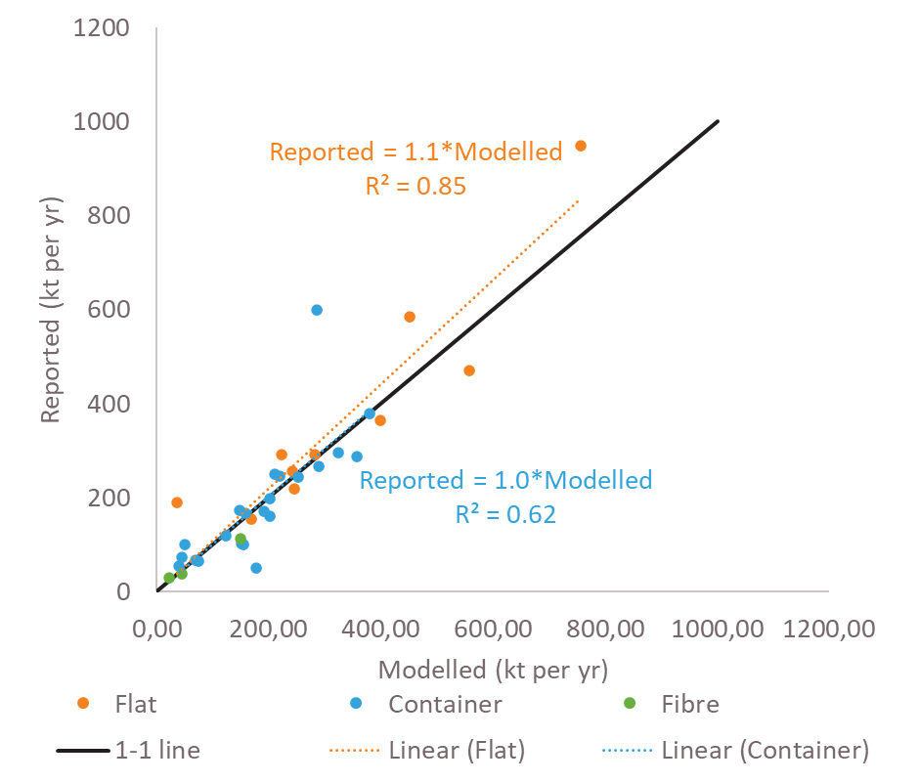
Figure 8 Validation of EF based estimates of production rates with reported production rates/capacities at the level of glass production sites.
- Overview production sites per route
According to the AIDRES database, the glass sector has a production rate of 44 million ton annually in the EU27. The majority (72%) is produced as container glass followed by flat (23%) and fibre glass (5%). Glass Europe reports a total glass production of 42 million ton annually at 190 installations in the EU27. Although the total production aligns, there some important differences for the glass fibre industry (Table 13) which can partly be explained by the number of installations considered (i.e. container glass).

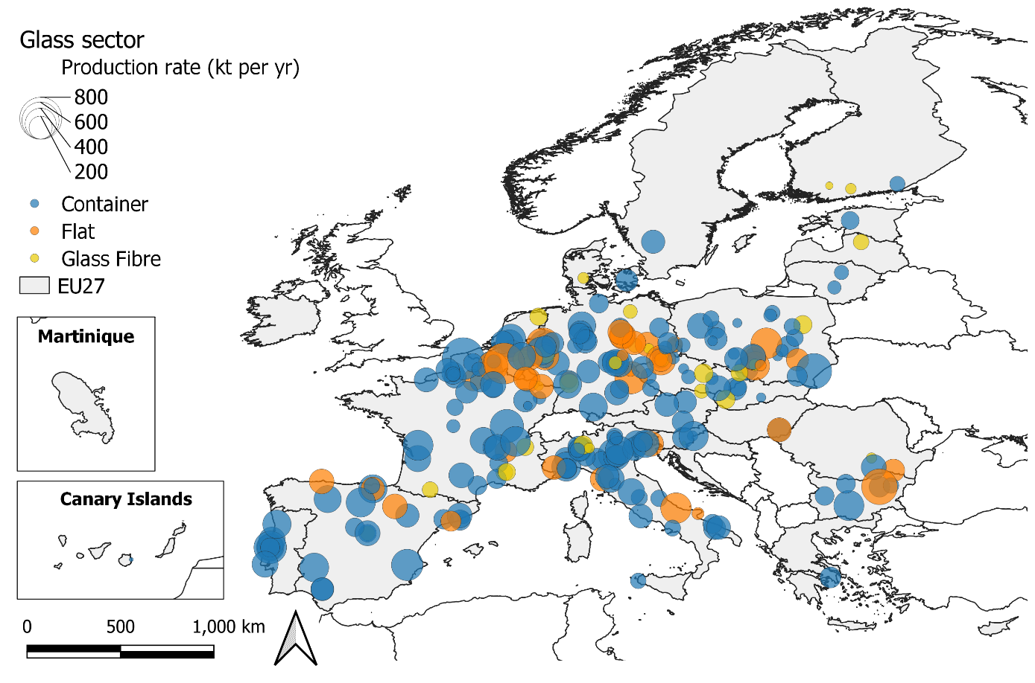Figure 9 Production rate (kt yr⁻¹) for glass production sites in the EU27.

Table 13 Total glass production rate per production types as included in the AIDRES db and reported by Glass Europe.
Product | Glass Europe (EU27) |  | AIDRES
 | # | kt yr⁻¹ | # | kt yr⁻¹
Flat | 37 | 10840 | 42 | 10072
Container | 141 | 22440 | 186 | 32020
Fibre | 12 | 8600 | 32 | 2100
Total | 190 | 41880 | 260 | 44192

A comparison with country specific glass production rates as reported in the Annual EU greenhouse gas inventory 1990-2019 and inventory report 2021 (EU NIR; accessed 1/07/2021) shows that the applied methodology performs better or worse depending on the country. The combination of a weak GHG methodology (T1) and data sources; GHG default value (D) or country specific value (CS) explain the observed variations between the AIDRES estimates and those reported in the GHG emission inventory. Additionally, some countries report production rates for raw products rather than the end product (e.g. Finland), and can therefore not be compared. The AIDRES database overestimates the glass production in most important producing countries with 10-20%.

Table 14 Country specific comparison of glass production rates as included in the AIDRES database and reported in the annual EU greenhouse gas (GHG) inventory report (2021).
Country | Description | Production rate (kt yr⁻¹) |  | Ratio | Method* | Data source&
 |  | GHG Inventory# | AIDRES | (GHG/AIDRES)
Austria | Glass production | 526 | 577 | 0.91 | T3 | PS
Belgium | Glass production | 1399 | 1402 | 1.00 | T3 | CS,PS
Bulgaria | - | 612 | 1416 | 0.43 | T1 | CS
Cyprus |  | NO
Czech Republic | Glass production | 1179 | 1688 | 0.70 | T3 | PS
Germany | Glass production | 7378 | 9311 | 0.79 | T2 | CS
Denmark | Glass production | 203 | 209 | 0.97 | T3 | PS
Estonia | Glass production | 87 | 109 | 0.80 | T3 | PS
Spain | Glass production | 4765 | 4354 | 1.09 | T3 | CS, D, PS
Finland | Used carbonates | 5 | 101 | 0.05 | T3 | CS
France | Glass production | 3365 | 7301 | 0.46 | T2,T3 | CS,PS
Greece | Glass production | 118 | 160 | 0.74 | CS | CS
Croatia | Glass production | 68 | 356 | 0.19 | T3 | PS
Hungary | Glass production | 365 | 415 | 0.88 | T3 | CS, PS
Ireland | Carbonate use | NO |  |  | NA | NA
Italy | Glass production | 6033 | 7741 | 0.78 | T2 | CS, PS
Lithuania | Glass production | 52 | 108 | 0.48 | T2 | D
Luxembourg | Glass production | 403 | 439 | 0.92 | CS | PS
Latvia | Glass production | C | 74 |  | T3 | D, PS
Netherlands |  | 1541 | 1278 | 1.21 | T3 | PS
Poland | Glass production | 3490 | 4064 | 0.86 | T2 | D
Portugal |  | 1788 | 2042 | 0.88 | T3 | OTH
Romania | Glass production | 359 | 460 | 0.78 | T2 | CS, D
Sweden |  | NE | 209 |  | T3 | CS, D
Slovenia | Glass production | 99 | 185 | 0.53 | T3 | D
Slovakia | Used carbonates | 43 | 426 | 0.10 | T3 | PS
EU27 |  | 33878 | 44428 | Avg. 0.71
#NO – not occurring, NE- removals/emissions are not estimated, NA – not applicable
*Method – T1 uses default emission factor (basic assessment), T2 takes into account abatement and differentiates in processes and T3 is based on measurements and detailed modelling.
&Source: D is default value, CS is country specific data and PS is plant specific data used to estimate total production at the country level, OTH is other source.
    - Pareto approach
Fertiliser sector
- Identified production routes (current technology options) and product types
The AIDRES database includes a total of 42 production sites (corresponding with >60 installations). The fertiliser sector focuses mainly on the energy-intensive production of N-fertilizers like ammonia, nitric acid but also the production of ammonium nitrate, urea and other nitrogen (N), phosphorus (P) and potassium (K) derivates are considered. Fertiliser production sites have typically strongly integrated processes to produce one or multiple end products at the same location.

- Industrial parameters
There is no publicly available database with fertiliser production capacity and rates at the level of production sites within the EU27. 30% of the production sites (12 out of 42) are responsible for more than 80% of the direct and indirect verified emissions in 2019.

Table 15 Ranking by highest verified emissions of companies at production sites which are responsible for 80% verified emissions in the fertilizer sector in 2019 (EUTL database). %Cum indicates the cumulative % of verified emissions of the ranked production sites compared to the total of all fertiliser production sites.
​Rank | Account holdername @ site​ | Country​ | VerifiedEmissions​ | %(Cum)​
1​ | Yara Sluiskil B.V. - SLUISKIL | NL | 3447301 | 16%
2​ | AB Achema - Jonavos raj. | LT | 2486023 | 28%
3​ | SKW Stickstoffwerke Piesteritz GmbH - Lutherstadt Wittenberg | DE | 2415738 | 40%
4​ | BASF SE - Ludwigshafen | DE | 1732975 | 48%
5​ | Petrokemija d.d. tvornica gnojiva - Kutina | HR | 1256815 | 54%
6​ | Borealis Agrolinz Melamine GmbH - Linz | AT | 1043777 | 59%
7​ | Duslo, a.s. - Šaľa | SK | 985847 | 64%
8​ | ANWIL S. A. - Włocławek | PL | 820336 | 68%
9​ | Nitrogénmûvek ZRt. - Pétfürdõ | HU | 811610 | 71%
10​ | BOREALIS CHIMIE SAS - MORMANT | FR | 796740 | 75%
11​ | Fertiberia, S.A. - Palos de la Frontera | ES | 702428 | 79%
12​ | BOREALIS CHIMIE SAS - LE GRAND QUEVILLY | FR | 682762 | 82%
A desktop study was conducted to collect information on the production capacity per site and product type. For modelling purposes, we collected industrial parameters per production site by product type (ammonia, nitric acid and derivates). Reported production capacity data were collected from annual reports, factbooks, site fact sheets, scientific publications, newspaper articles, permit reports and national databases for 40 production sites. A median ammonia production capacity of 405 kt yr⁻¹ (Rizos et al., 2014) was attributed to production sites for which no reported data is available. In this way, a production capacity estimate is available for 100% of the production sites and representative for 100% of the 2019 verified emissions in the ETS db. Production capacities could be separated by product type for every site, and a total production capacity was attributed.

Table 16 Number and total production capacity (kt yr⁻¹) of fertiliser production sites (2020) per product type as derived from the EUTL database and included in the AIDRES db. Compared with those reported in the annual EU greenhouse gas (GHG) inventory report (2021).
Product type |  | Total production (kt yr⁻¹)
 | #sites& | AIDRES* | GHG Inventory (2018)
ammonia | 30 | 14,700 | 11,911
nitric acid | 26 | 11,800 | 14,968
derivates | 29 | 34,100 | na
combined | 3 | 2,800 | na
*Countries without production sites in the EUTL: Romania and Italy
& One production sites can produce different end products.

- Overview production sites per route
According to the AIDRES database, the fertiliser sector has an ammonia production rate of 15.8 million ton annually in the EU27 which are further used to produce about 12 million ton nitric acid and over 34 million ton derivates like urea and ammonium nitrate. Fertilizers Europe reports that about 120 production installations in Europe (including the UK) produced 18.1 million tonnes of nutrient in 2018 from which 13.5 million N-fertilisers.
The modelling effort reports on the production of ammonia as a product and feedstock for other fertilisers. The model applies an utilization factor of 0.69 on 15.8, resulting in an ammonia production rate of 10.9 million ton annually for the EU27. Nitric acid and derivates product flows are not geographically projected on NUTS3 level. However, energy and emission intensities are available in the database for future purpose.

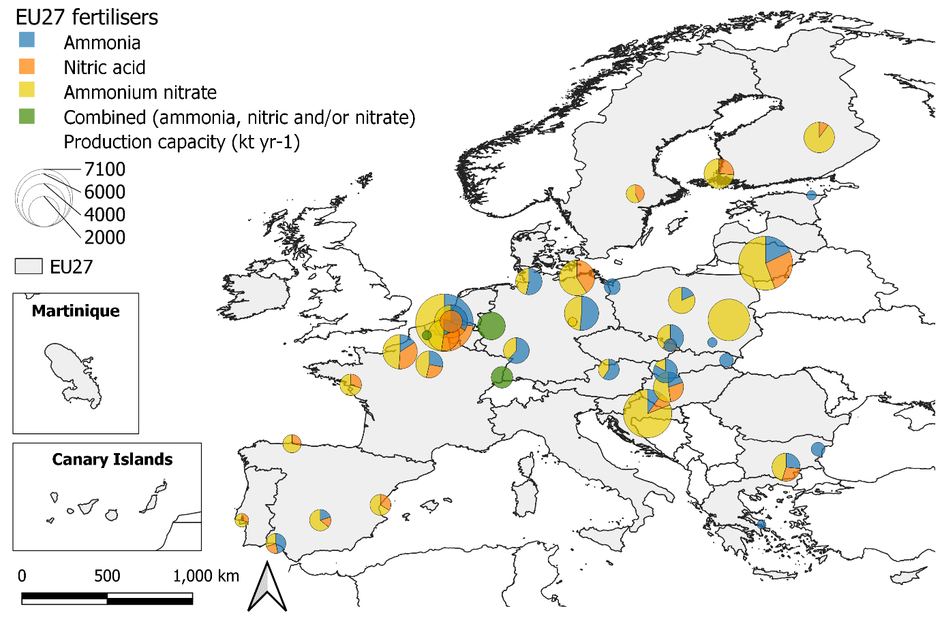
Figure 10 Production capacity (kt yr⁻¹) for fertilizer production sites in the EU27.
A comparison with country specific ammonia and nitric acid production rates as reported in the Annual EU greenhouse gas inventory 1990-2019 and inventory report 2021 (EU NIR; accessed 1/07/2021) show that the total production capacity at EU level roughly align for ammonia but that there are important country-specific differences.

Table 17 Country specific comparison of fertiliser production capacities as included in the AIDRES database and reported in the annual EU greenhouse gas (GHG) inventory report (2021).
Country* | GHG Inventory - Production rate (kt yr⁻¹) |  | AIDRES Production capacity (kt yr⁻¹) |  | Ratio (AIDRES/GHG)
 | Ammonia | Nitric | Ammonia | Nitric | Ammonia | Nitric
Austria | 405 | 430 | 555 | n.a. | 1.37 | n.a.
Belgium | 975 | 2042 | 1200 | 1762 | 1.23 | 0.86
Czech Republic | 179 | 579 | 350 | n.a. | 1.96 | n.a.
Germany | 3030 | 2669 | 3628 | 1100 | 1.20 | 0.41
Spain | 531 | 716 | 600 | 875 | 1.13 | 1.22
Finland |  | 650 |  | 700 |  | 1.08
France | 1112 | 1961 | 1419 | 1600 | 1.28 | 0.82
Greece | 148 | 190 | 165 | n.a. | 1.11
Croatia | 397 | 289 | 496 | 460 | 1.25 | 1.59
Hungary |  | 790 | 385 | 540 |  | 0.68
Italy | 611 | 447
Lithuania | 948 | 1050 | 1117 | 1650 | 1.18 | 1.57
Poland | 2535 | 2310 | 1614 | n.a. | 0.64
Romania | 524 |  | n.a.
Sweden |  | 269 |  | 300 |  | 1.12
Slovakia | 517 | 575 | 1418 | 204 | 2.74 | 0.35
*For Italy, Romania, Poland some important production sites are missing in the EUTL database. N.a. is not available.

Due to the integrated nature of the chemical and fertilizer sectors, reporting on production and emissions is complex and often aligned with the requirements of an official data request which hampers a straightforward comparison between reports. Importantly, an almost complete inventory of reported production capacity is made for all the ETS production installations within the activity code 38 and 41 of the EUTL database.

Figure 11 Comparison of country specific production rates for ammonia and nitric acid included in the database, reported in the annual EU greenhouse gas (GHG) inventory report (2021) and by the CEPS study (2014)

Chemical sector
- Identified production routes (current technology options)
The AIDRES database includes a total of 258 chemical production sites (corresponding with >380 installations). The chemical sector is a complex sector with a large variation in industrial processes and linked energy and material requirements. Through the blue-print models this complexity is abstracted to three main production routes (cracker, organic synthesis and polymerisation). Production sites for carbon black, soda and synthesis gases are not included in the industrial parameters inventory and modelling exercise. Chemical production sites typically have strongly integrated processes and produce one or multiple end products at the same location. Table 18 reports the number of sites with a specific production route and the total reported production capacity as collected during the desktop inventory.

Table 18 Number of total and inventarised production sites (2020) per production route as derived from the EUTL database and reported production capacities (kt yr⁻¹) as retrieved from official documents and databases.
Production route | #Sites | #Inventarised sites | Reported production capacity (kt yr⁻¹)
cracker | 23 | 15 | 12101
organic synthesis | 60 | 17 | 17749
polymers | 51 | 21 | 17747
combined | 22 | 8 | 16860
not identified | 92 |  | na

- Industrial parameters
There is no publicly available database with chemical production capacity and rates at the level of production sites within the EU27. In total 26 out of 258 production sites (or 178 out of 387 ETS installations) are responsible for about 80% of the direct and indirect verified emissions in 2019.

A desktop study was conducted to collect information on the production capacity for all 26 production site per production route and, if available, per product type. Reported production capacity data were collected from annual reports, factbooks, site fact sheets, scientific publications, newspaper articles, permit reports and national databases. The level of detail on production routes differs between sites and depending on the source where actual installed versus permitted capacity is reported. During the desktop study, we equally included reported production capacities for smaller sites when available in the reviewed documents, databases and websites. Not for every site production capacities could be separated by production route. Instead a total production capacity was attributed (i.e. combined). For modelling purposes, a default production capacity will be used for all smaller sites spread across the EU27 that are responsible for the remaining 20% of the verified emissions. Where possible production routes were identified for these smaller sites by combining the EUTL activity description, the Nace code and some additional manual checks. Unfortunately, for 92 production sites the production route remains unidentified. No utilisation factor is used to convert production capacity to rates.

Table 19 Rank of companies at production sites which are responsible for 80% of the 2019 verified emissions in the chemical sector (EUTL database). %Cum indicates the cumulative % of verified emissions of the ranked production sites compared to the total of all chemical production sites.
​Rank | Account holdername @ site​ | Country​ | VerifiedEmissions​ | %(Cum)​
1​ | BASF SE​ | DE​ | 5079893​ | 9%​
2​ | Polski Koncern Naftowy ORLEN S.A.​ | PL​ | 5071774​ | 18%​
3​ | DOW Benelux B.V.​ | NL​ | 4041723​ | 25%​
4​ | B.A.S.F. Antwerpen​ | BE​ | 2912091​ | 31%​
5​ | Basell Polyolefine GmbH​ | DE​ | 2687923​ | 35%​
6​ | Evonik Operations GmbH​ | DE​ | 2275247​ | 40%​
7​ | SHELL Nederland Chemie B.V.​ | NL​ | 2315969​ | 44%​
8​ | INEOS Manufacturing Deutschland GmbH​ | DE​ | 2314567​ | 48%​
9​ | Versalis S.p.A.​ | IT​ | 2150812​ | 52%​
10​ | CIECH Soda Polska S.A.​ | PL​ | 2141183​ | 56%​
11​ | Grupa Azoty Zakłady Azotowe Kędzierzyn Spółka Akcyjna​ | PL​ | 1203547​ | 58%​
12​ | Solvay Química S.L.​ | ES​ | 1142156​ | 60%​
13​ | Solvay ChemicalsGmbH​ | DE​ | 1120526​ | 62%​
14​ | SLOVNAFT, a.s.​ | SK​ | 1109125​ | 64%​
15​ | Dow ChemicalIberica, SL​ | ES​ | 1088533​ | 66%​
16​ | Repsol Química, SA​ | ES​ | 1083019​ | 68%​
17​ | Dow OlefinverbundGmbH​ | DE​ | 1013245​ | 69%​
18​ | MOL PetrolkémiaZrt.​ | HU​ | 988254​ | 71%​
19​ | Total OlefinsAntwerp​ | BE​ | 768132​ | 73%​
20​ | VERSALIS FRANCE SAS​ | FR​ | 610998​ | 74%​
21​ | Wacker Chemie AG​ | DE​ | 539606​ | 75%​
22​ | Evonik Antwerpen​ | BE​ | 529682​ | 76%​
23​ | Dow Deutschland Anlagengesellschaft mbH​ | DE​ | 489308​ | 76%​
24​ | Cepsa Química S.A​ | ES​ | 474131​ | 77%​
25​ | INOVYN Manufacturing Belgium​ | BE​ | 459836​ | 78%​
26​ | SOLVAY OPERATIONS FRANCE​ | FR​ | 415059​ | 79%​

Following default production capacity are used for each site in the EU27 that are responsible for the remaining 20% of the verified emissions:
- Cracker (incl. ethylene (33%), propylene (17%) and other olefins (50%)): 43.6 kt yr⁻¹
- Organic synthesis: 43.4 kt yr⁻¹
- Polymers: 47.2 kt yr⁻¹
These are proportionally derived from the reported production capacities of the sites responsible for 80% of the verified emissions. In other words, those responsible for 20% of the verified emissions are also responsible for 20% of the total chemical production.

Default production capacities were allocated to production sites as follows:
- If based on the Nace code, permit or petrochemical databases the actual production route present at this site is known (cracker, organic synthesis or polymers) only the corresponding defaut value was attributed. This was the case in 45% of the sites.
- In the remaining 55% of the sites with undefined production routes, a default value for each production route was attributed to the site.
We did not scale the default values in function of their size (e.g. verified emissions).

From the expert review, we observed some cracker installations were missing. Therefore a cross-comparison was made for the crackers with the publicly available cracker database which reports on ethylene production capacities. Due to the nature of the EUTL database, some cracker installation that are part of an integrated refinery will not be reported separately. In case they are omitted from the EUTL, these sites were manually added to the database.

- Overview production sites per route
According to the AIDRES database, the production sites responsible for about 80% of all verified emissions have a total production capacity of 67 million ton annually in the EU27. As a result of including the sites responsible for the remaining 20% of the emissions and missing crackers at integrated refineries, the AIDRES database identified an annual production of 97.7 million ton chemicals distributed over crackers (39.3 mio yr⁻¹), polymers (32.4 mio yr⁻¹) and organic synthesis (26 mio yr⁻¹) in the EU-27. The modelling effort focuses on olefins for crackers, polyethylene for the polymerization and poly-ethyl-acetate for organic synthesis as end-product equivalents. In the model, a utilization factor of 0.84 was used to estimate production rates of olefins. Utilization factors were not available for polyethylene and poly-ethyl-acetate.

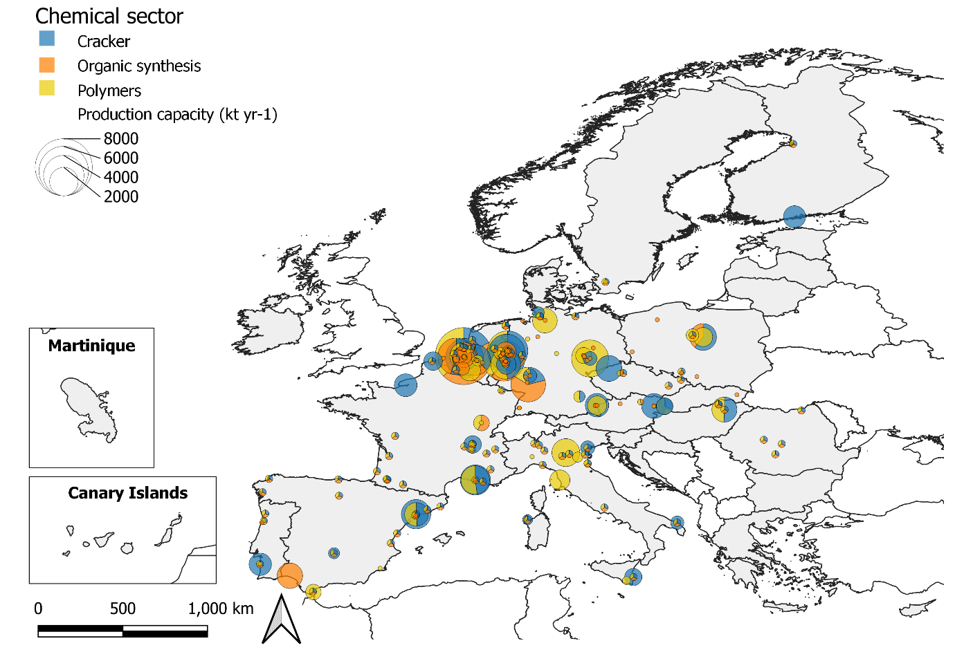
Figure 12 Production capacity (kt yr⁻¹) for chemical production sites in the EU27.
References
- Simon Pezzutto, Stefano Zambotti, Silvia Croce, Pietro Zambelli, Giulia Garegnani, Chiara Scaramuzzino, Ramón Pascual Pascuas, Alyona Zubaryeva, Franziska Haas, Dagmar Exner (EURAC), Andreas Mueller (e-think), Michael Hartner (TUW), Tobias Fleiter, Anna-Lena Klingler, Matthias Kuehnbach, Pia Manz, Simon Marwitz, Matthias Rehfeldt, Jan Steinbach, Eftim Popovski (Fraunhofer ISI) Reviewed by Lukas Kranzl, Sara Fritz (TUW) Hotmaps Project, D2.3 WP2 Report – Open Data Set for the EU28, 2018 www.hotmaps-project.eu

- Rizos, V., Infelise, F., Luchetta, G., Simonelli, F., Stoefs, W., Timini, J. and Colantoni, L. (2014). For a study on composition and rivers of energy prices and costs in energy intensive industries: the case of the chemical industry – ammonia. CEPS study (ENTR/2008/006Lot4).

- European Steel in Figures, EUROFER 2020. https://www.eurofer.eu/assets/Uploads/European-Steel-in-Figures-2020.pdf Last accessed 1/04/2021.
ANNEX 1 - Classification of EUTL activity codes/descriptions into AID-RES specific industrial sectors
ACTIVITY_TYPE_CODE | ACTIVITY_TYPE_DESCRIPTION | AIDRES_Sector | #Installations
6 | Installations for the production of cement clinker in rotary kilns or lime in rotary kilns or in other furnaces | Cement | 22
29 | Production of cement clinker | Cement | 201
30 | Production of lime, or calcination of dolomite/magnesite | Cement | 230
37 | Production of carbon black | Chemical | 17
39 | Production of adipic acid | Chemical | 3
40 | Production of glyoxal and glyoxylic acid | Chemical | 1
42 | Production of bulk chemicals | Chemical | 316
43 | Production of hydrogen and synthesis gas | Chemical | 39
44 | Production of soda ash and sodium bicarbonate | Chemical | 11
38 | Production of nitric acid | Fertiliser | 32
41 | Production of ammonia | Fertiliser | 25
7 | Installations for the manufacture of glass including glass fibre | Glass | 20
31 | Manufacture of glass | Glass | 304
2 | Mineral oil refineries | Refinery | 6
21 | Refining of mineral oil | Refinery | 110
3 | Coke ovens | Steel | 0
5 | Installations for the production of pig iron or steel (primary or secondary fusion) including continuous casting | Steel | 11
22 | Production of coke | Steel | 15
24 | Production of pig iron or steel | Steel | 192
25 | Production or processing of ferrous metals | Steel | 200
1 | Combustion installations with a rated thermal input exceeding 20 MW | Other | 466
4 | Metal ore (including sulphide ore) roasting or sintering installations | Other | 0
8 | Installations for the manufacture of ceramic products by firing, in particular roofing tiles, bricks, refractory bricks, tiles, stoneware or porcelain | Other | 57
9 | Industrial plants for the production of (a) pulp from timber or other fibrous materials (b) paper and board | Other | 56
10 | Aircraft operator | Other | 970
20 | Combustion of fuels | Other | 5388
23 | Metal ore roasting or sintering | Other | 8
26 | Production of primary aluminium | Other | 20
27 | Production of secondary aluminium | Other | 25
28 | Production or processing of non-ferrous metals | Other | 82
32 | Manufacture of ceramics | Other | 876
33 | Manufacture of mineral wool | Other | 35
34 | Production or processing of gypsum or plasterboard | Other | 37
35 | Production of pulp | Other | 143
36 | Production of paper or cardboard | Other | 474
45 | Capture of greenhouse gases under Directive 2009/31/EC | Other | 0
46 | Transport of greenhouse gases under Directive 2009/31/EC | Other | 1
47 | Storage of greenhouse gases under Directive 2009/31/EC | Other | 0
99 | Other activity opted-in pursuant to Article 24 of Directive 2003/87/EC | Other | 208

GETTING IN TOUCH WITH THE EU
In person
All over the European Union there are hundreds of Europe Direct information centres. You can find the address of the centre nearest you at: https://europa.eu/european-union/contact_en
On the phone or by email
Europe Direct is a service that answers your questions about the European Union. You can contact this service:
– by freephone: 00 800 6 7 8 9 10 11 (certain operators may charge for these calls),
– at the following standard number: +32 22999696, or
– by email via: https://europa.eu/european-union/contact_en

FINDING INFORMATION ABOUT THE EU
Online
Information about the European Union in all the official languages of the EU is available on the Europa website at: https://europa.eu/european-union/index_en
EU publications
You can download or order free and priced EU publications from: https://op.europa.eu/en/publications. Multiple copies of free publications may be obtained by contacting Europe Direct or your local information centre (see https://europa.eu/european-union/contact_en).
EU law and related documents
For access to legal information from the EU, including all EU law since 1952 in all the official language versions, go to EUR-Lex at: http://eur-lex.europa.eu
Open data from the EU
The EU Open Data Portal (http://data.europa.eu/euodp/en) provides access to datasets from the EU. Data can be downloaded and reused for free, for both commercial and non-commercial purposes.

[Catalogue number]

EPOS project, funded by the European Union’s Horizon 2020 research and innovation programme under grant agreement No 679386
Download https://ec.europa.eu/clima/ets/ provided by DG CLIMA (February 2021).
Download "Classification of installations in the EUTL Registry based on the NACE 4 statistical classification" on 25.02.2021 from https://ec.europa.eu/clima/policies/ets/allowances/leakage_en#tab-0-2
Download Industrial Reporting Database v3 December 2020: https://www.eea.europa.eu/data-and-maps/data/industrial-reporting-under-the-industrial
Download “Hotmaps Project, D2.3 WP2 Report – Open Data Set for the EU28, 2018 https://www.hotmaps-project.eu/” (Pezzutto et al., 2018) on 16/02/2021 from https://gitlab.com/hotmaps/industrial_sites/industrial_sites_Industrial_Database/-/tree/master
Download of NUTS 2021 - version date 01/02/2020 - scale 1:1 million (most detailed) - LEVL_3.shp with EPSG 4326 on https://ec.europa.eu/eurostat/web/gisco/geodata/reference-data/administrative-units-statistical-units/nuts#nuts13
The EPOS project: https://www.spire2030.eu/epos with description https://www.spire2030.eu/sites/default/files/users/user222/Epos-docs/HullPC/Blueprints.pdf
World steel association website: https://www.worldsteel.org/media-centre/press-releases/2021/june-2021-crude-steel-production.html (accessed 1/04/2021)
Concawe – Refineries Map: https://www.concawe.eu/refineries-map/ (accessed 1/05/2021)
Petrochemicals Europe – Refineries and steam crackers in EU-28 (2019) - https://www.petrochemistry.eu/about-petrochemistry/petrochemicals-facts-and-figures/maps-refineries-and-crackers/ (accessed 1/05/2021)
Fuels Europe – Refinery/steam cracker sites in Europe - https://www.fuelseurope.eu/data-room/refinery-steam-cracker-sites-in-europe/ (accessed 1/05/2021)
S&P Globals – Refinery news roundup: https://www.spglobal.com/platts/en/market-insights/latest-news/oil/060920-refinery-news-roundup-european-refiners-restart-plants-units
Petrochemicals Europe – Cracker capacity in EU-28 (2019) – https://www.petrochemistry.eu/about-petrochemistry/petrochemicals-facts-and-figures/cracker-capacity/ (accessed 1/05/2021)
Fuels Europe – Statistics (Refining) - https://www.fuelseurope.eu/publications/publications/fuelseurope-statistical-report-2021(accessed 09/11/2022)
EU NIR; accessed 1/07/2021 - https://www.eea.europa.eu/publications/annual-european-union-greenhouse-gas-inventory-2021
CEMBUREAU activity report 2019 (EU28); accessed 1/07/2021 https://cembureau.eu/media/clkdda45/activity-report-2019.pdf combined with UK specific data from Annual MPA report 2020 https://cement.mineralproducts.org/documents/2020-09-26_Annual_cementitious.pdf.
‘Glass’. https://ec.europa.eu/growth/sectors/raw-materials/related-industries/non-metallic-products-and-industries/glass_en (accessed Nov. 09, 2021).
EC Update of benchmark values for the years 2021-2025 of phase 4 of the EU ETS (accessed 1/07/2021) - https://climate.ec.europa.eu/system/files/2021-10/policy_ets_allowances_bm_curve_factsheets_en.pdf
Industrial Value Chain – A bridge towards a carbon neutral Europe (Wyns et al., 2018; IEB): https://www.ies.be/files/Industrial_Value_Chain_25sept_0.pdf
Recycling: why recycling always has a happy ending (FEVE): https://feve.org/wp-content/uploads/2016/04/FEVE-brochure-Recycling-Why-glass-always-has-a-happy-CO2-ending-.pdf
Fertilizers Europe: Industry fact and figures 2020 (accessed 1/07/2021): https://www.fertilizerseurope.com/wp-content/uploads/2020/07/Industry-Facts-and-Figures-2020-spreads.pdf
Petrochemicals Europe – Cracker capacity in EU-28 (2019) – https://www.petrochemistry.eu/about-petrochemistry/petrochemicals-facts-and-figures/cracker-capacity/ (accessed 1/05/2021)

